“Know your enemy, know his sword.” wrote Miyamoto Musashi in his book, A Book of Five Rings: The Classic Guide to Strategy. He also wrote, “You win battles by knowing the enemy’s timing, and using a timing which the enemy does not expect.” Although this was written when swords and spears won battles, it also applies to cyberspace, where attacks are launched via keyboards and crafted packets. The more you know about your target’s infrastructure and personnel, the better you can orchestrate your attacks.
In a red team operation, you might start with no more than a company name, from which you need to start gathering information about the target. This is where reconnaissance comes into play. Reconnaissance (recon) can be defined as a preliminary survey or observation of your target (client) without alerting them to your activities. If your recon activities create too much noise, the other party would be alerted, which might decrease the likelihood of your success.
The tasks of this room cover the following topics:
- Types of reconnaissance activities
- WHOIS and DNS-based reconnaissance
- Advanced searching
- Searching by image
- Google Hacking
- Specialized search engines
- Recon-ng
- Maltego
Some specific objectives we'll cover include:
- Discovering subdomains related to our target company
- Gathering publicly available information about a host and IP addresses
- Finding email addresses related to the target
- Discovering login credentials and leaked passwords
- Locating leaked documents and spreadsheets
Reconnaissance can be broken down into two parts — passive reconnaissance and active reconnaissance, as explained in Task 2. In this room, we will be focusing on passive reconnaissance, i.e., techniques that don’t alert the target or create 'noise'. In later rooms, we will use active reconnaissance tools that tend to be noisy by nature.
Reconnaissance (recon) can be classified into two parts:
- 1, Passive Recon: can be carried out by watching passively
- 2, Active Recon: requires interacting with the target to provoke it in order to observe its response.
Passive recon doesn't require interacting with the target. In other words, you aren't sending any packets or requests to the target or the systems your target owns. Instead, passive recon relies on publicly available information that is collected and maintained by a third party. Open Source Intelligence (OSINT) is used to collect information about the target and can be as simple as viewing a target's publicly available social media profile. Example information that we might collect includes domain names, IP address blocks, email addresses, employee names, and job posts. In the upcoming task, we'll see how to query DNS records and expand on the topics from the Passive Reconnaissance room and introduce advanced tooling to aid in your recon.
Active recon requires interacting with the target by sending requests and packets and observing if and how it responds. The responses collected - or lack of responses - would enable us to expand on the picture we started developing using passive recon. An example of active reconnaissance is using Nmap to scan target subnets and live hosts. Other examples can be found in the Active Reconnaissance room. Some information that we would want to discover include live hosts, running servers, listening services, and version numbers.
Active recon can be classified as:
- 1, External Recon: Conducted outside the target's network and focuses on the externally facing assets assessable from the Internet. One example is running Nikto from outside the company network.
- 2, Internal Recon: Conducted from within the target company's network. In other words, the pentester or red teamer might be physically located inside the company building. In this scenario, they might be using an exploited host on the target's network. An example would be using Nessus to scan the internal network using one of the target’s computers.
This task focuses on:
- whois
- dig, nslookup, host
- traceroute/tracert
Before we start using the whois tool, let's look at WHOIS. WHOIS is a request and response protocol that follows the RFC 3912 specification. A WHOIS server listens on TCP port 43 for incoming requests. The domain registrar is responsible for maintaining the WHOIS records for the domain names it is leasing. whois will query the WHOIS server to provide all saved records. In the following example, we can see whois provides us with:
- Registrar WHOIS server
- Registrar URL
- Record creation date
- Record update date
- Registrant contact info and address (unless withheld for privacy)
- Admin contact info and address (unless withheld for privacy)
- Tech contact info and address (unless withheld for privacy)
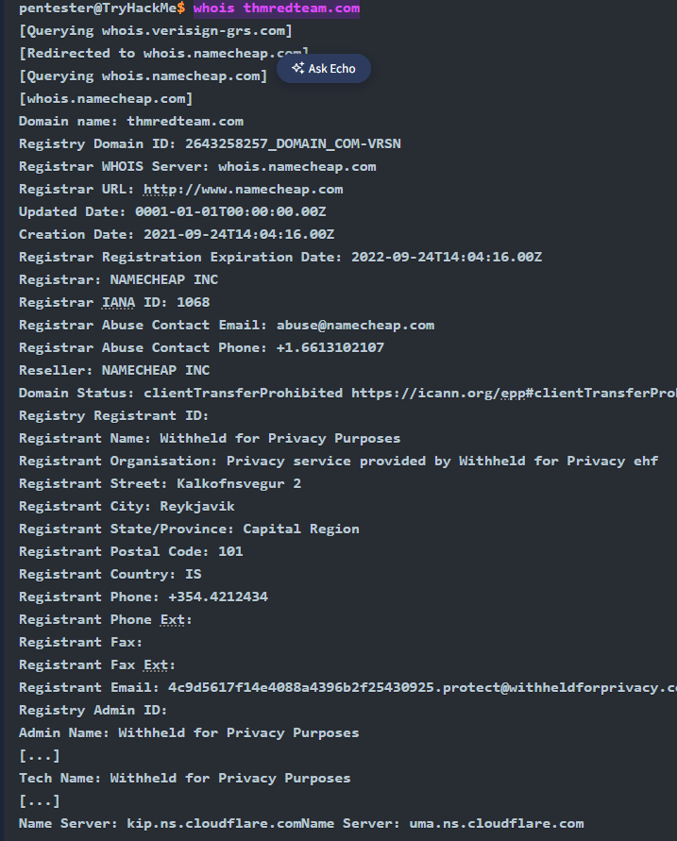

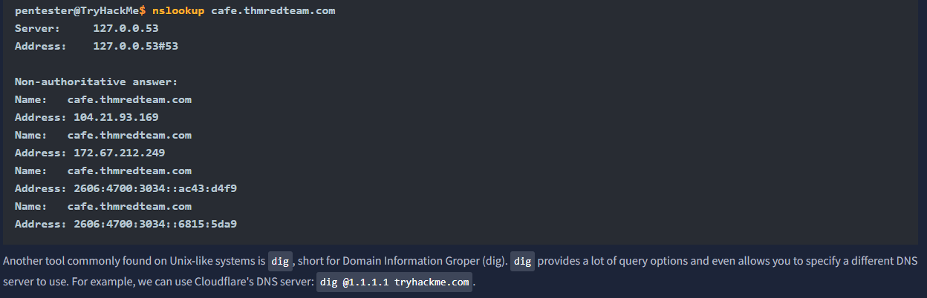
host cafe.thmredteam.com
traceroute cafe.thmredteam.com
In summary, we can always rely on:
whois to query the WHOIS database
nslookup, dig, or host to query DNS servers
WHOIS databases and DNS servers hold publicly available information, and querying either does not generate any suspicious traffic.
Moreover, we can rely on Traceroute (traceroute on Linux and macOS systems and tracert on MS Windows systems) to discover the hops between our system and the target host.

When was thmredteam.com created (registered)? (YYYY-MM-DD)
To how many IPv4 addresses does clinic.thmredteam.com resolve?
To how many IPv6 addresses does clinic.thmredteam.com resolve?

Note: In addition to pdf, other filet ypes to consider are:
- doc, docx, ppt, pptx, xls and xlsx.
Each search engine might have a slightly varied set of rules and syntax. To learn about the specific syntax for the different search engines, you will need to visit their respective help pages. Some search engines, such as Google, provide a web interface for advanced searches: Google Advanced Search. Other times, it is best to learn the syntax by heart, such as Google Refine Web Searches, DuckDuckGo Search Syntax, and Bing Advanced Search Options.
Search engines crawl the world wide web day and night to index new web pages and files. Sometimes this can lead to indexing confidential information. Examples of confidential information include:
- Documents for internal company use
- Confidential spreadsheets with usernames, email addresses, and even passwords
- Files containing usernames
- Sensitive directories
- Service version number (some of which might be vulnerable and unpatched)
- Error messages
Combining advanced Google searches with specific terms, documents containing sensitive information or vulnerable web servers can be found. Websites such as Google Hacking Database (GHDB) collect such search terms and are publicly available. Let's take a look at some of the GHDB queries to see if our client has any confidential information exposed via search engines. GHDB contains queries under the following categories:
- Footholds
Consider GHDB-ID: 6364 as it uses the query intitle:"index of" "nginx.log" to discover Nginx logs and might reveal server misconfigurations that can be exploited.
- Files Containing Username For example, GHDB-ID: 7047 uses the search term intitle:"index of" "contacts.txt" to discover files that leak juicy information.
- Sensitive Directories For example, consider GHDB-ID: 6768, which uses the search term inurl:/certs/server.key to find out if a private RSA key is exposed.
- Web Server Detection Consider GHDB-ID: 6876, which detects GlassFish Server information using the query intitle:"GlassFish Server - Server Running".
- Vulnerable Files For example, we can try to locate PHP files using the query intitle:"index of" "*.php", as provided by GHDB-ID: 7786.
- Vulnerable Servers For instance, to discover SolarWinds Orion web consoles, GHDB-ID: 6728 uses the query intext:"user name" intext:"orion core" -solarwinds.com.
- Error Messages Plenty of useful information can be extracted from error messages. One example is GHDB-ID: 5963, which uses the query intitle:"index of" errors.log to find log files related to errors.
You might need to adapt these Google queries to fit your needs as the queries will return results from all web servers that fit the criteria and were indexed. To avoid legal issues, it is best to refrain from accessing any files outside the scope of your legal agreement.
We recommend you join the Google Dorking room for more in-depth information.
Now we'll explore two additional sources that can provide valuable information without interacting with our target:
- Social Media
- Job ads

Social Media
Social media websites have become very popular for not only personal use but also for corporate use. Some social media platforms can reveal tons of information about the target. This is especially true as many users tend to overshare details about themselves and their work. To name a few, it's worthwhile checking the following:
- LinkedIn
- Twitter
- Facebook
- Instagram
Social media websites make it easy to collect the names of a given company's employees; moreover, in certain instances, you might learn specific pieces of information that can reveal answers to password recovery questions or gain ideas to include in a targeted wordlist. Posts from technical staff might reveal details about a company’s systems and vendors. For example, a network engineer who was recently issued Juniper certifications may allude to Juniper networking infrastructure being used in their employer’s environment.

Job Ads
Job advertisements can also tell you a lot about a company. In addition to revealing names and email addresses, job posts for technical positions could give insight into the target company’s systems and infrastructure. The popular job posts might vary from one country to another. Make sure to check job listing sites in the countries where your client would post their ads. Moreover, it is always worth checking their website for any job opening and seeing if this can leak any interesting information.
Note that the Wayback Machine can be helpful to retrieve previous versions of a job opening page on your client’s site.

How would you search using Google for xls indexed for http://clinic.thmredteam.com?
site:clinic.thmredteam.com filetype:xls
- The website actually has XLS files
- Google has indexed those files
- The files aren't blocked by robots.txt or other restrictions
- The files are accessible without authentication

How would you search using Google for files with the word passwords for http://clinic.thmredteam.com?
The search site:clinic.thmredteam.com "passwords" is a reconnaissance technique used to find unintentionally exposed sensitive information. Its primary purpose is to discover if any documents or web pages on the clinic.thmredteam.com domain contain the word "passwords" and have been indexed by Google.
This is a classic example of "Google Dorking" or using Google Hacking Database (GHDB) queries, which is a common first step in authorized penetration testing and cyber security research.

HOIS and DNS Related
Beyond the standard WHOIS and DNS query tools that we covered in Task 3, there are third parties that offer paid services for historical WHOIS data. One example is WHOIS history, which provides a history of WHOIS data and can come in handy if the domain registrant didn’t use WHOIS privacy when they registered the domain.
There are a handful of websites that offer advanced DNS services that are free to use. Some of these websites offer rich functionality and could have a complete room dedicated to exploring one domain. For now, we'll focus on key DNS related aspects. We will consider the following:
- ViewDNS.info
- Threat Intelligence Platform

ViewDNS.info
ViewDNS.info offers Reverse IP Lookup. Initially, each web server would use one or more IP addresses; however, today, it is common to come across shared hosting servers. With shared hosting, one IP address is shared among many different web servers with different domain names. With reverse IP lookup, starting from a domain name or an IP address, you can find the other domain names using a specific IP address(es).
In the figure below, we used reverse IP lookup to find other servers sharing the same IP addresses used by cafe.thmredteam.com. Therefore, it is important to note that knowing the IP address does not necessarily lead to a single website.
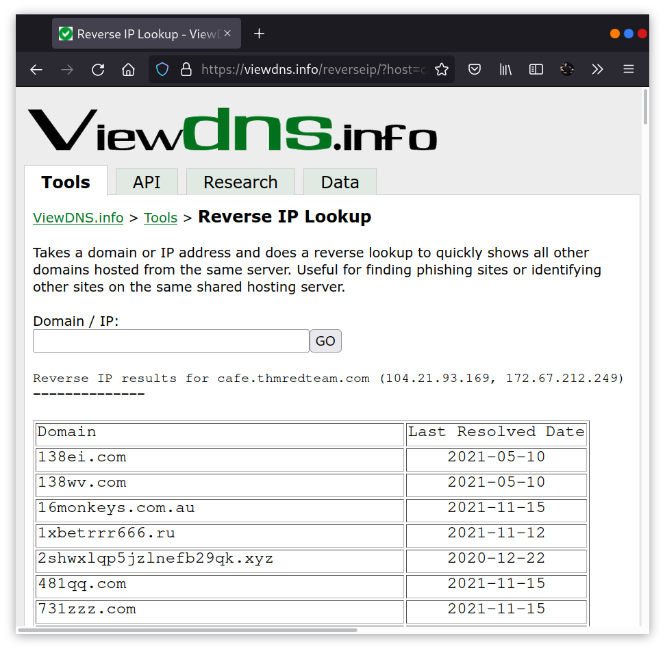

Threat Intelligence Platform
Threat Intelligence Platform requires you to provide a domain name or an IP address, and it will launch a series of tests from malware checks to WHOIS and DNS queries. The WHOIS and DNS results are similar to the results we would get using whois and dig, but Threat Intelligence Platform presents them in a more readable and visually appealing way. There is extra information that we get with our report. For instance, after we look up thmredteam.com, we see that Name Server (NS) records were resolved to their respective IPv4 and IPv6 addresses, as shown in the figure below.
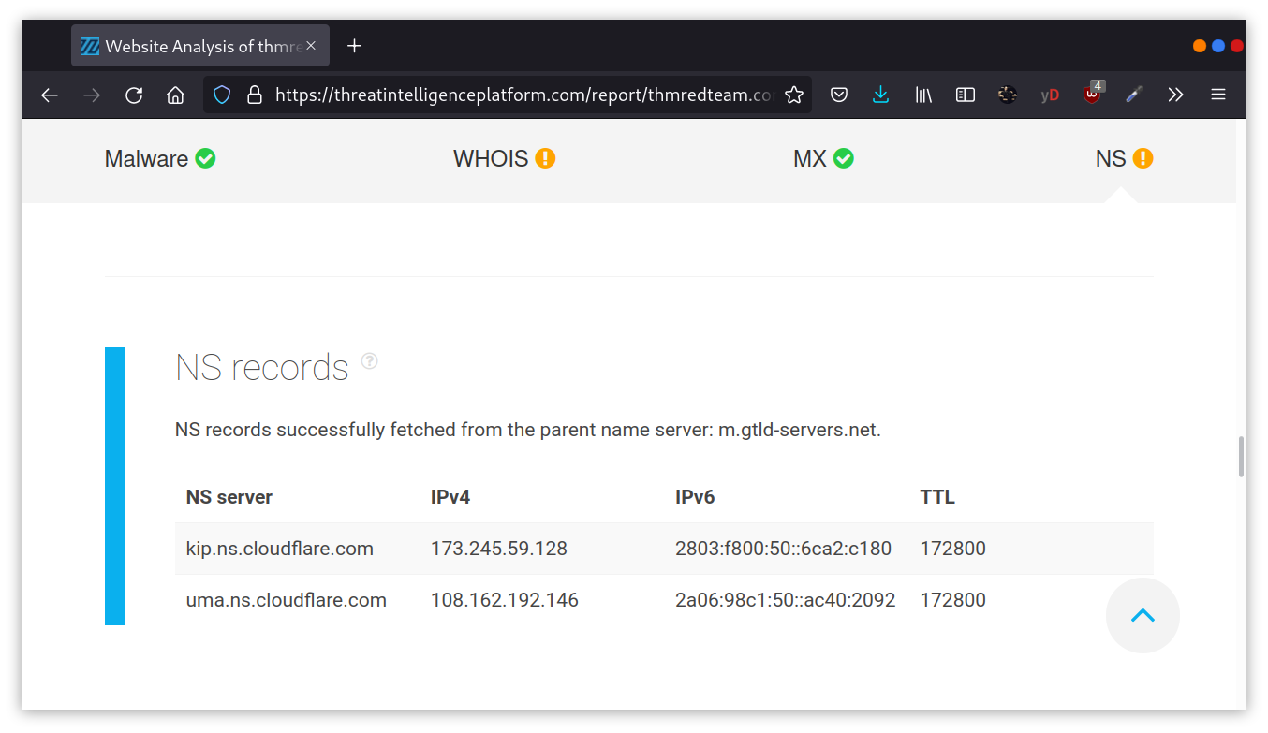
On the other hand, when we searched for cafe.thmredteam.com, we could also get a list of other domains on the same IP address. The result we see in the figure below is similar to the results we obtained using ViewDNS.info.
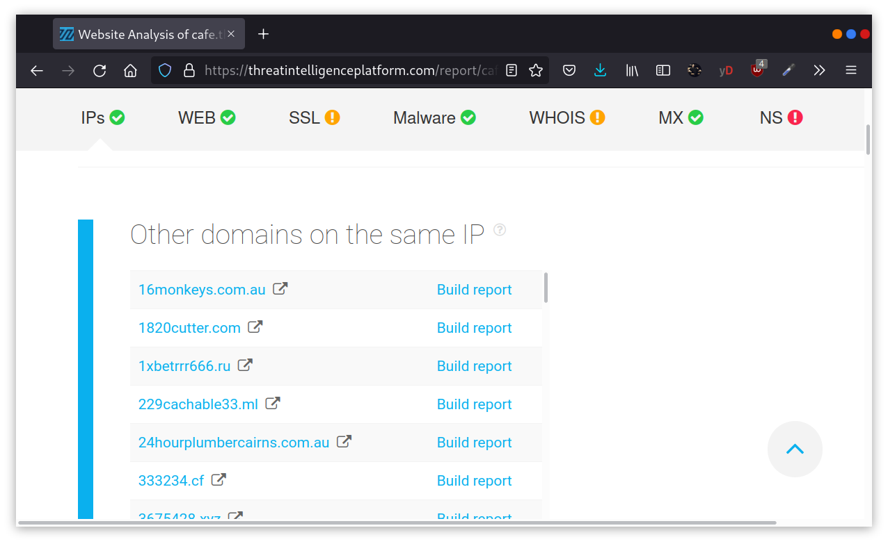

Specialized Search Engines

Censys
Censys Search can provide a lot of information about IP addresses and domains. In this example, we look up one of the IP addresses that cafe.thmredteam.com resolves to. We can easily infer that the IP address we looked up belongs to Cloudflare. We can see information related to ports 80 and 443, among others; however, it's clear that this IP address is used to server websites other than cafe.thmredteam.com. In other words, this IP address belongs to a company other than our client, Organic Cafe. It's critical to make this distinction so that we don’t probe systems outside the scope of our contract.
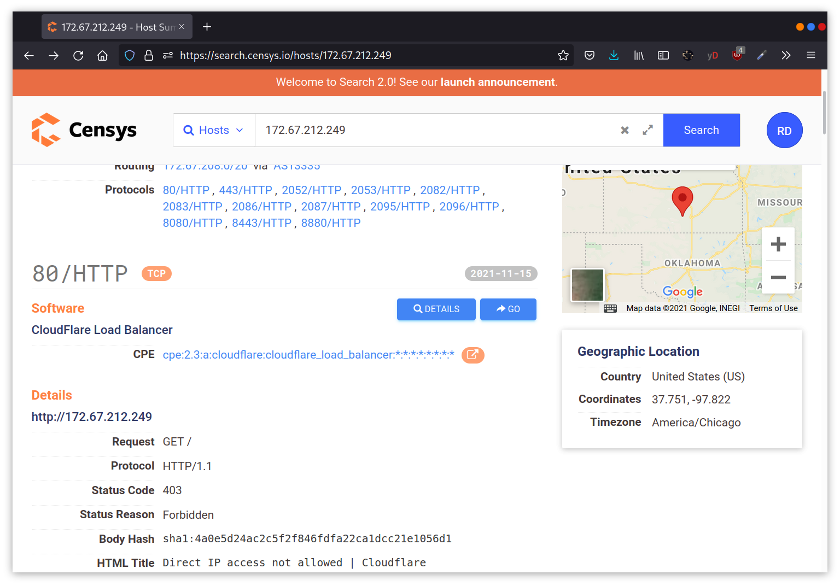

Shodan
You might remember using Shodan in the Passive Reconnaissance room. In this section, we will demonstrate how to use Shodan from the command line.
To use Shodan from the command-line properly, you need to create an account with Shodan, then configure shodan to use your API key using the command, shodan init API_KEY.
You can use different filters depending on the type of your Shodan account. To learn more about what you can do with shodan, we suggest that you check out Shodan CLI. Let’s demonstrate a simple example of looking up information about one of the IP addresses we got from nslookup cafe.thmredteam.com. Using shodan host IP_ADDRESS, we can get the geographical location of the IP address and the open ports, as shown below.
What is the shodan command to get your Internet-facing IP address?
# Install Shodan CLI
pip install shodan
# Initialize with your API key
shodan init YOUR_API_KE
# Check your IP
shodan myip
How do you start recon-ng with the workspace clinicredteam?
recon-ng -w clinicredteam
- The -w flag specifies the workspace name
- Workspaces keep your data organized and separate for different projects
- All database entries, results, and settings are stored within the workspace
- If the workspace doesn't exist, it will be created automatically
- You can switch between workspaces using workspaces load <name> inside Recon-ng
How many modules with the name virustotal exist?

By writing ioc: 212192.246.30:5555 on this site Whois-RWS you can see the
